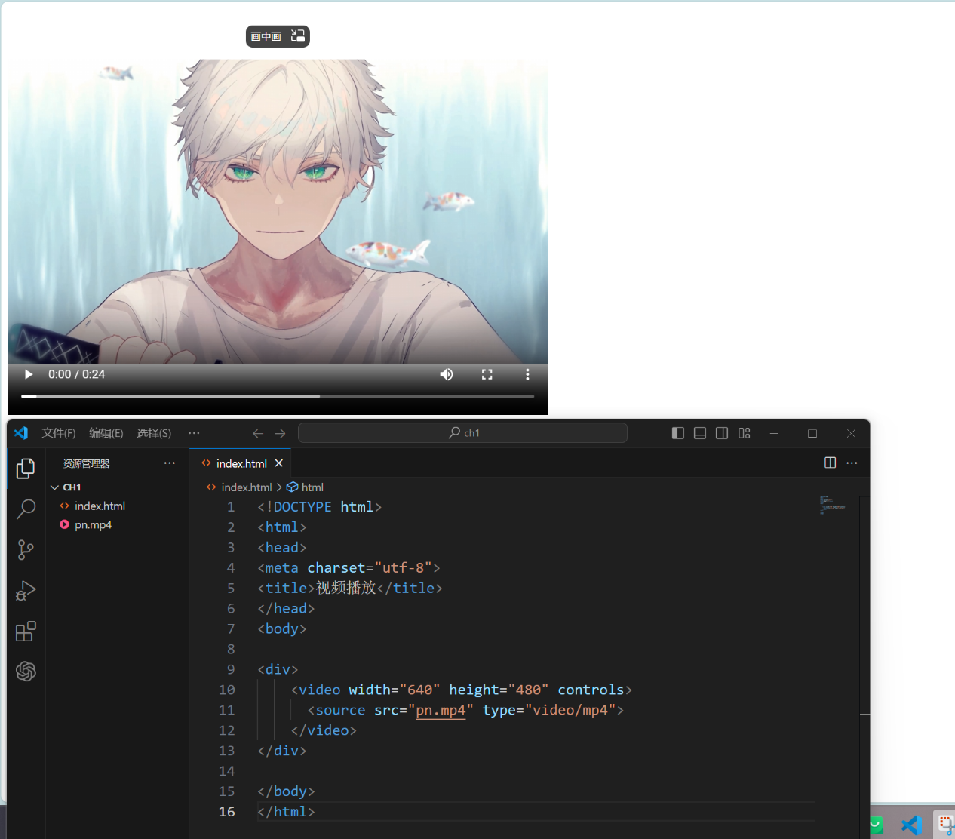

<!DOCTYPE html>

<html>

<head>

<meta charset="utf-8">

<title>视频播放</title>

</head>

<body>

<div>

    <video width="640" height="480" controls>

      <source src="pn.mp4" type="video/mp4">

    </video>

</div>

</body>

</html>

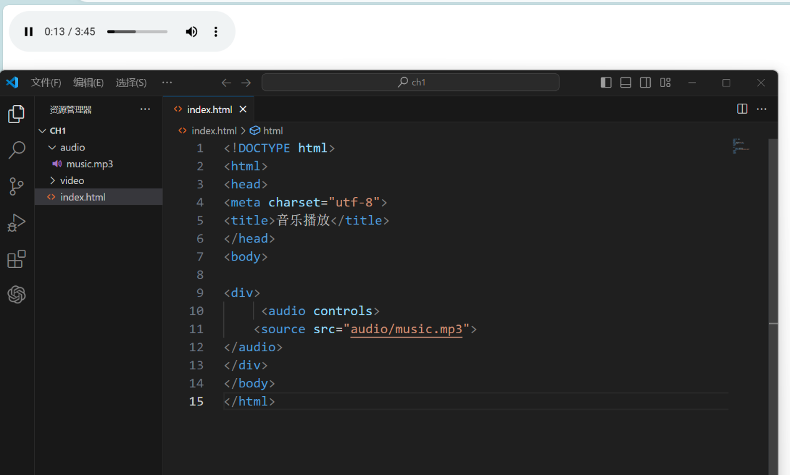

<!DOCTYPE html>

<html>

<head>

<meta charset="utf-8">

<title>音乐播放</title>

</head>

<body>

<div>

     <audio controls>

    <source src="audio/music.mp3">

</audio>

</div>

</body>

</html>